Comp Sys Arch Notes

DAY ONE

Patterson and hennesy

Set up a compiler that allows you to build native windows programs

Beginning of lecture

Deterministic Finite Automata (DFA)

* Fetch-decode-execute
* Initial state
* States
* Final / accept state
* Transitions
* Alphabet
* Epsilon (empty string)

List states visited for written homework on DFAs

Example 2 DFA

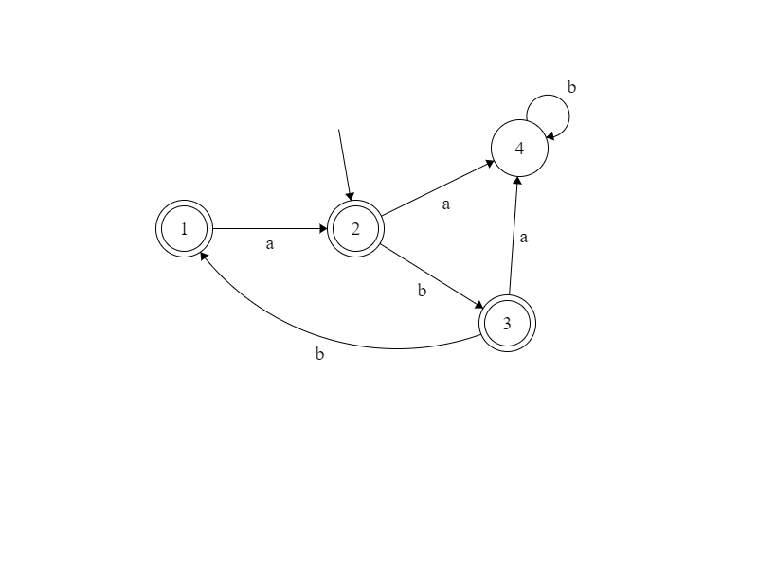

Strings that…

* Start and end with ‘a’

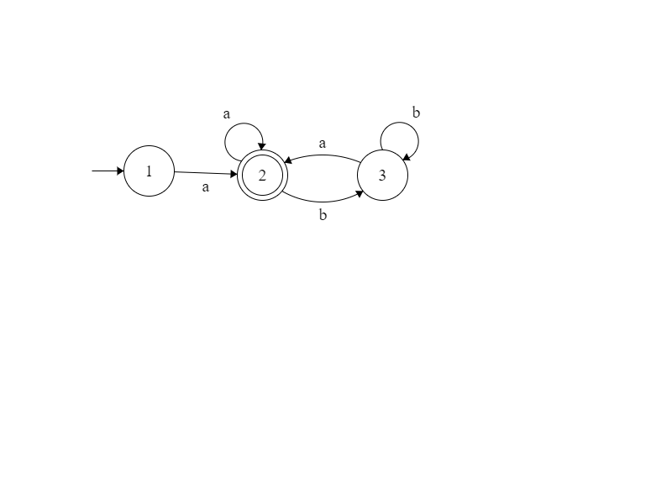

* ‘a’……’b’ OR ‘b’……’a’

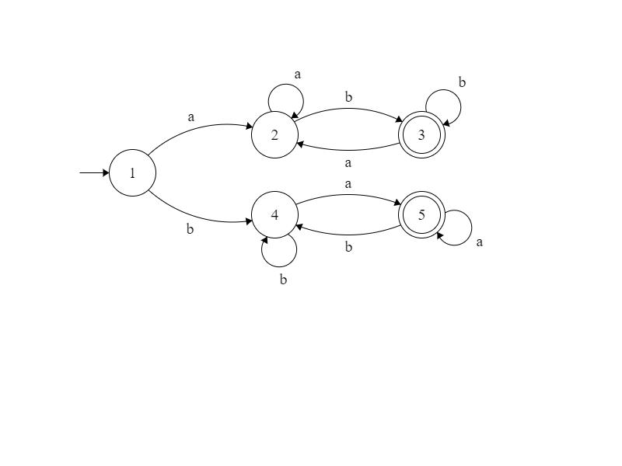

* Have exactly 3 ‘b’s

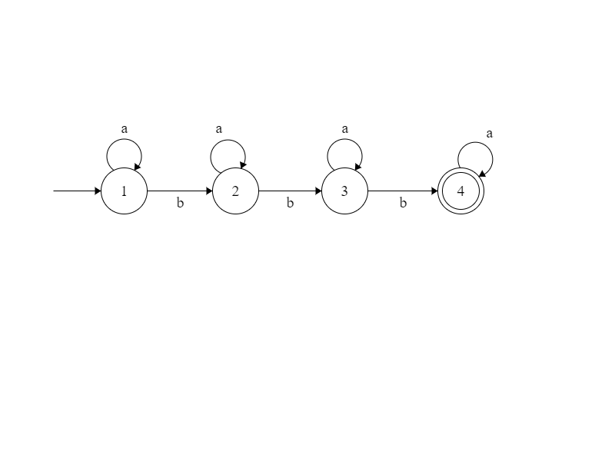

* Have 2 + ‘a’s and 2 + ‘b’s
* That have substring ‘aab’ but not ‘baa’